姓名：谢孟 | 专业：信息管理与信息系统 | 班级：20181171 | 学号：2018117112
科目：Android应用开发 |  | 实验日期： 2021.07.05
实验题目：第七章
【实验目的】

【实验内容】
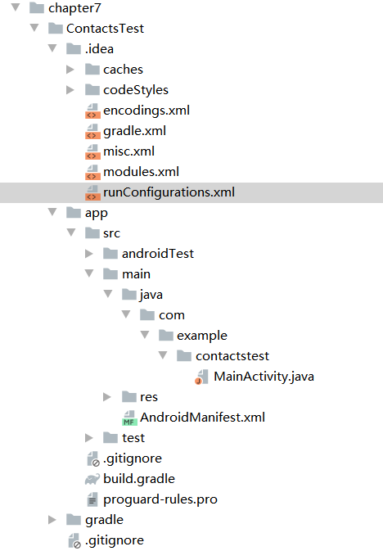
- 关键代码：

runConfigurations.xml:
<?xml version="1.0" encoding="UTF-8"?>
<project version="4">
<component name="RunConfigurationProducerService">
<option name="ignoredProducers">
<set>
<option value="org.jetbrains.plugins.gradle.execution.test.runner.AllInPackageGradleConfigurationProducer" />
<option value="org.jetbrains.plugins.gradle.execution.test.runner.TestClassGradleConfigurationProducer" />
<option value="org.jetbrains.plugins.gradle.execution.test.runner.TestMethodGradleConfigurationProducer" />
</set>
</option>
</component>
</project>
MainActivity.java:
package com.example.contactstest;

import android.Manifest;
import android.content.pm.PackageManager;
import android.database.Cursor;
import android.provider.ContactsContract;
import android.support.annotation.NonNull;
import android.support.v4.app.ActivityCompat;
import android.support.v4.content.ContextCompat;
import android.support.v7.app.AppCompatActivity;
import android.os.Bundle;
import android.widget.ArrayAdapter;
import android.widget.ListView;
import android.widget.Toast;

import java.util.ArrayList;
import java.util.List;

public class MainActivity extends AppCompatActivity {

ArrayAdapter<String> adapter;

List<String> contactsList = new ArrayList<>();

@Override
protected void onCreate(Bundle savedInstanceState) {
super.onCreate(savedInstanceState);
setContentView(R.layout.activity_main);
ListView contactsView = (ListView) findViewById(R.id.contacts_view);
adapter = new ArrayAdapter<String>(this, android.R.layout. simple_list_item_1, contactsList);
contactsView.setAdapter(adapter);
if (ContextCompat.checkSelfPermission(this, Manifest.permission.READ_CONTACTS) != PackageManager.PERMISSION_GRANTED) {
ActivityCompat.requestPermissions(this, new String[]{ Manifest.permission.READ_CONTACTS }, 1);
} else {
readContacts();
}
}

private void readContacts() {
Cursor cursor = null;
try {
// 查询联系人数据
cursor = getContentResolver().query(ContactsContract.CommonDataKinds.Phone.CONTENT_URI, null, null, null, null);
if (cursor != null) {
while (cursor.moveToNext()) {
// 获取联系人姓名
String displayName = cursor.getString(cursor.getColumnIndex(ContactsContract.CommonDataKinds.Phone.DISPLAY_NAME));
// 获取联系人手机号
String number = cursor.getString(cursor.getColumnIndex(ContactsContract.CommonDataKinds.Phone.NUMBER));
contactsList.add(displayName + "\n" + number);
}
adapter.notifyDataSetChanged();
}
} catch (Exception e) {
e.printStackTrace();
} finally {
if (cursor != null) {
cursor.close();
}
}
}

@Override
public void onRequestPermissionsResult(int requestCode, String[] permissions, int[] grantResults) {
switch (requestCode) {
case 1:
if (grantResults.length > 0 && grantResults[0] == PackageManager.PERMISSION_GRANTED) {
readContacts();
} else {
Toast.makeText(this, "You denied the permission", Toast.LENGTH_SHORT).show();
}
break;
default:
}
}

}

2.实验结果：
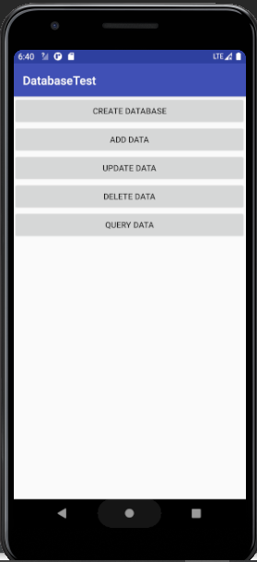
【教师评语和成绩】

成绩： 指导教师： 日期：

